**Deploying a Serverless Application Using AWS Lambda, API Gateway, and DynamoDB**

**Hands-on Lab**

We are going to create and host an entirely serverless application leveraging some of the most popular AWS offerings. We will deploy the application using an architecture that uses Amazon API Gateway, AWS Lambda, and Amazon DynamoDB.

**Objectives**

* Create the DynamoDB Table
* Create Lambda Functions
* Create Regional REST API
* Create Lambda Function Roles
* Deploy, Log, and Test

**Architecture**

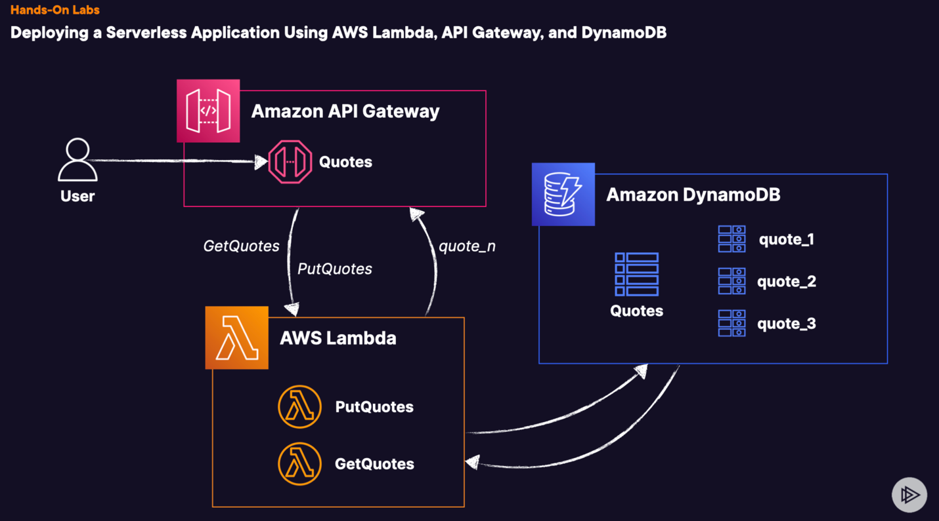

We are going to create a table called quotes and that is going to be connected with 2 lambda functions, PullQuotes and GetQuotes and we are going to use this functions to interact with this table. With the PUT function we are going to add new quotes and the GET function is going to pull these quotes and is going to give us a random one. To invoke these functions we are going to create an API Gateway, we will invoke via URL given to us from our stage for our RESTFULL API and using different resources for that URL for our API Gateway, we will interact with the 2 lambda functions.

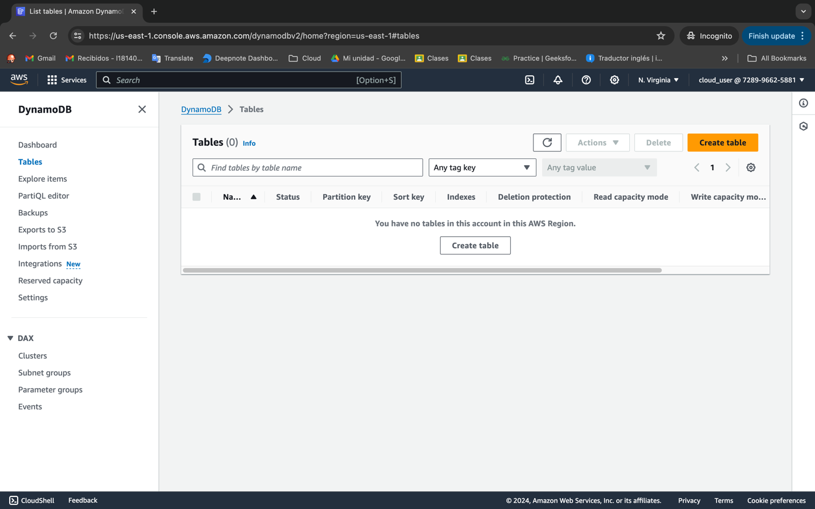

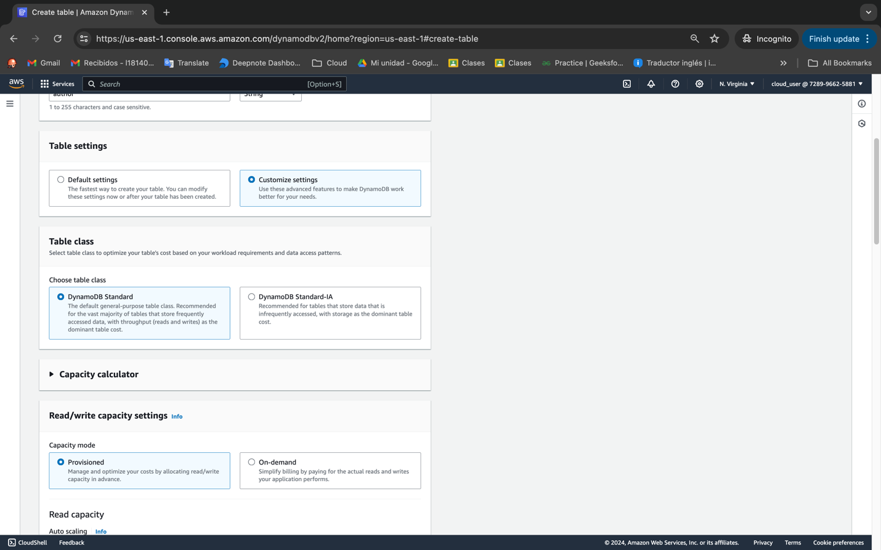

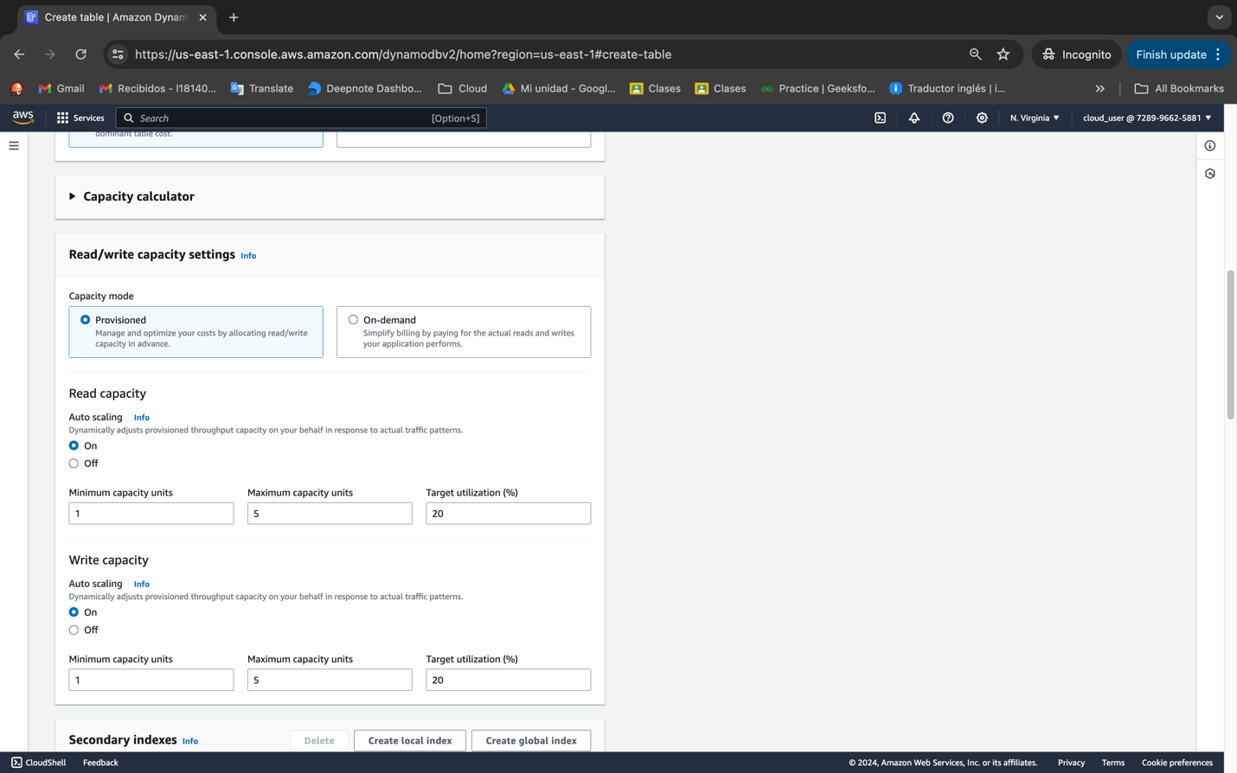

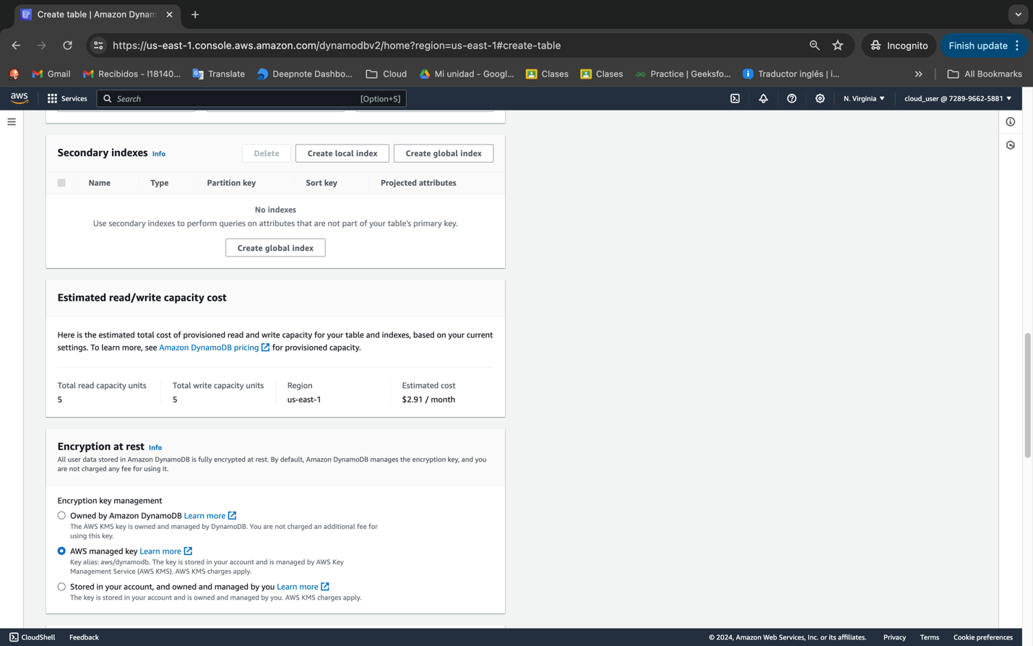

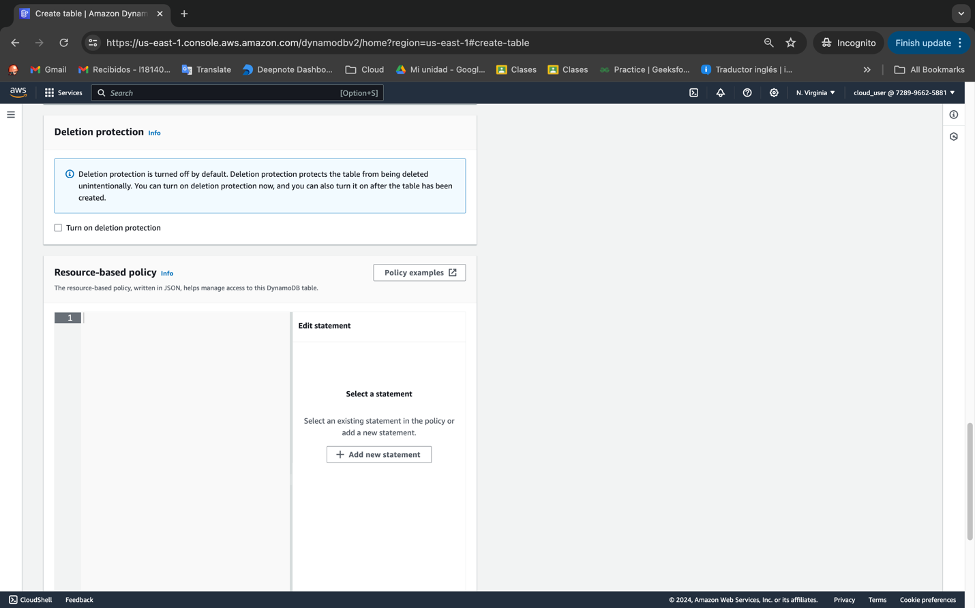

Low utilization app / 20 scale

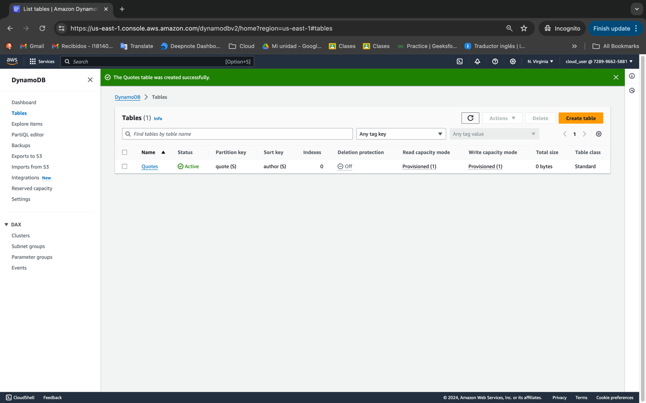

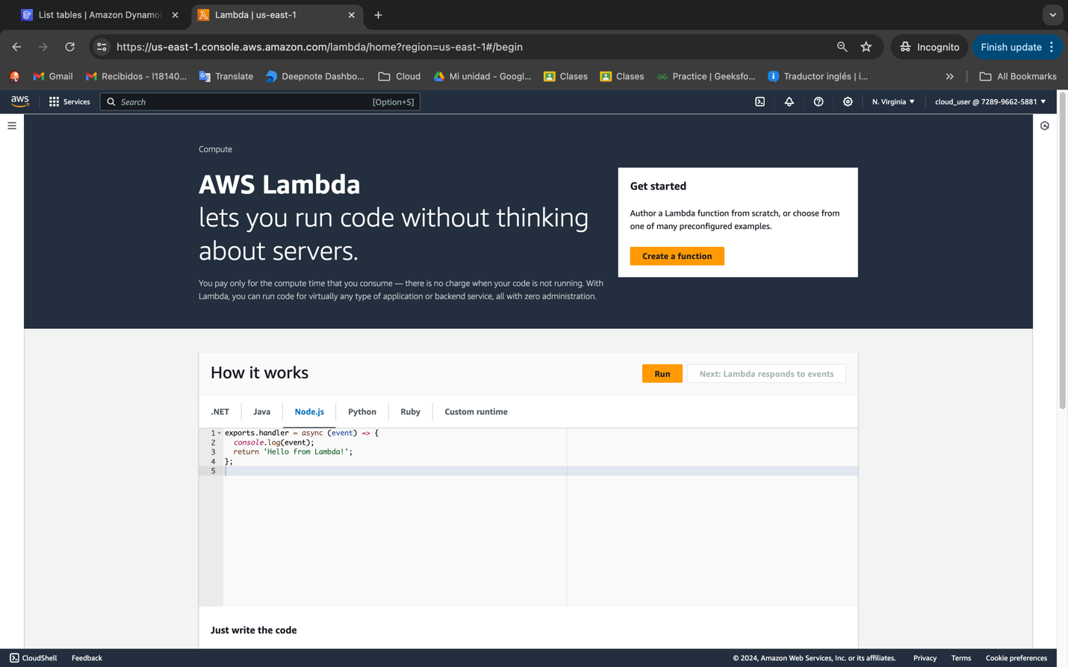

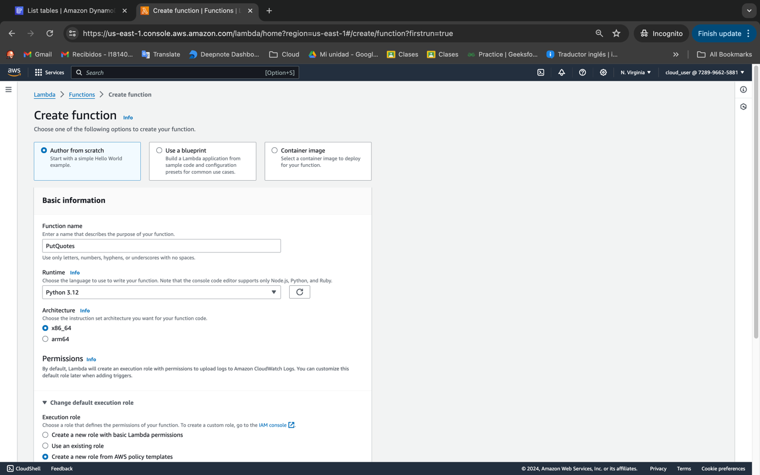

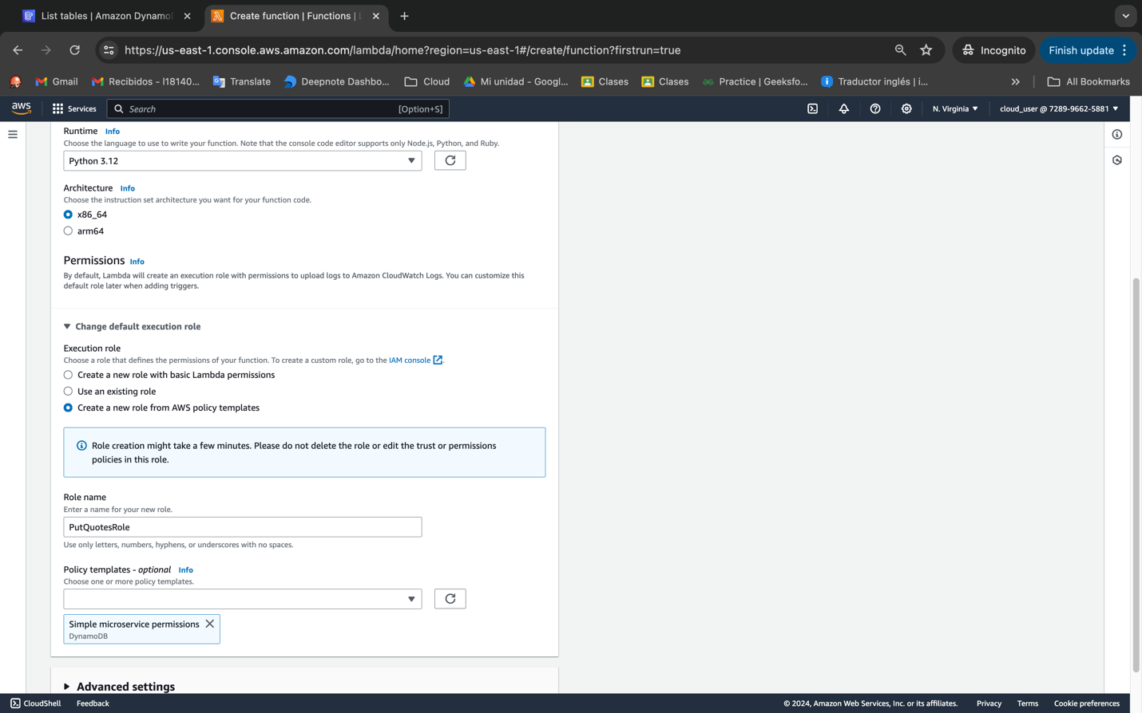

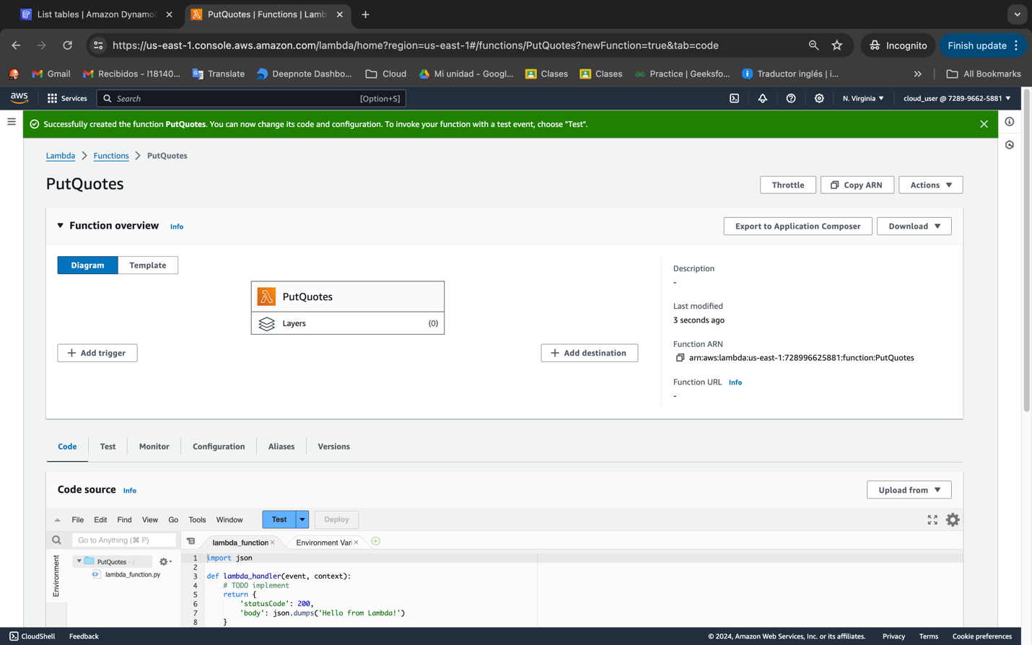

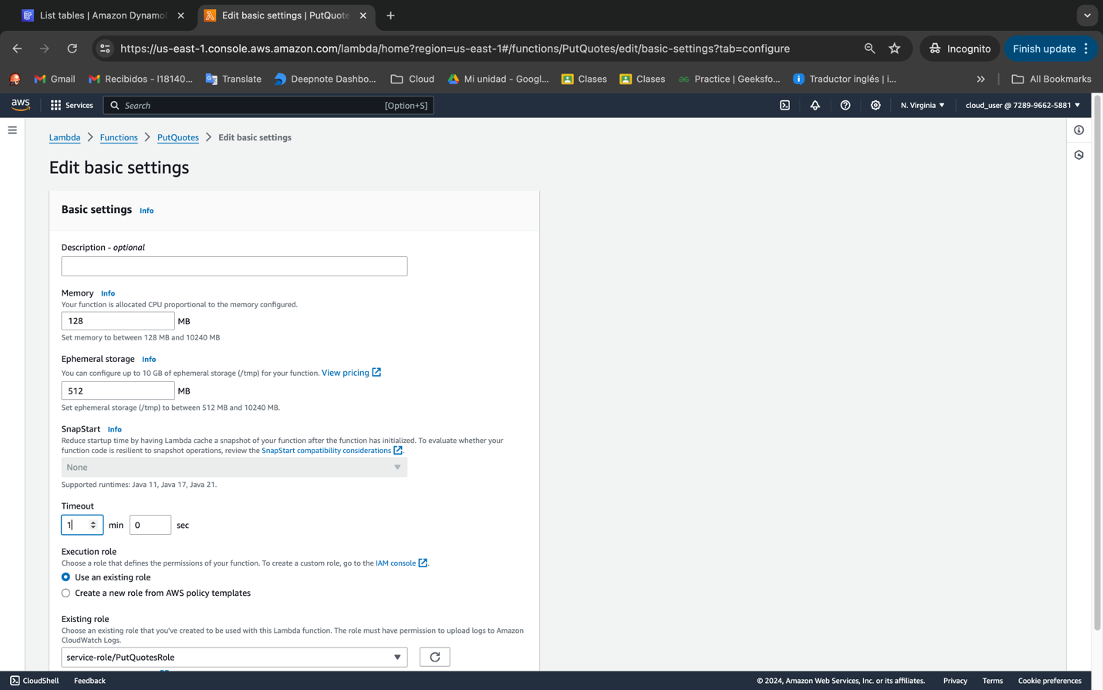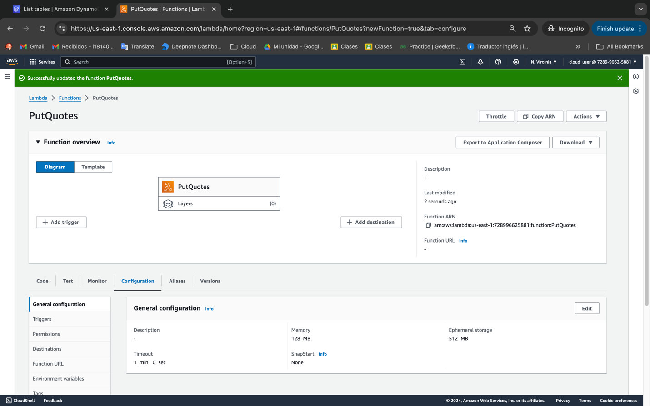

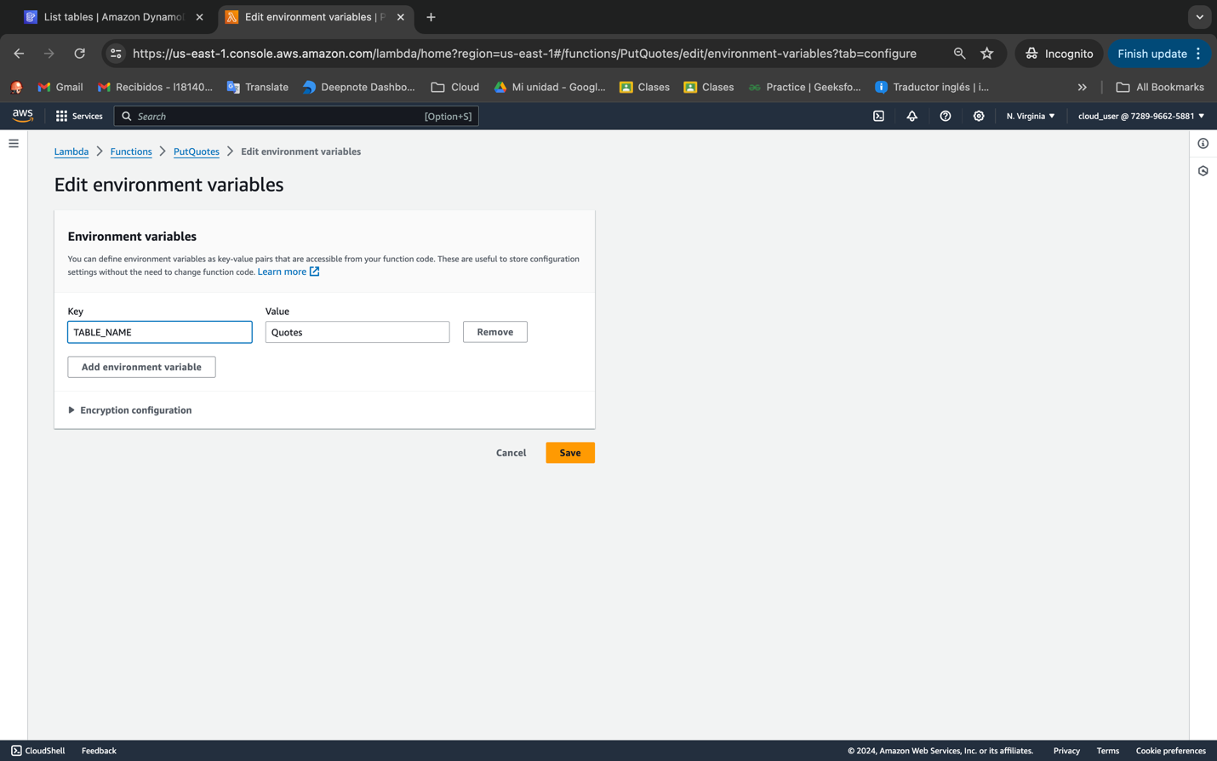

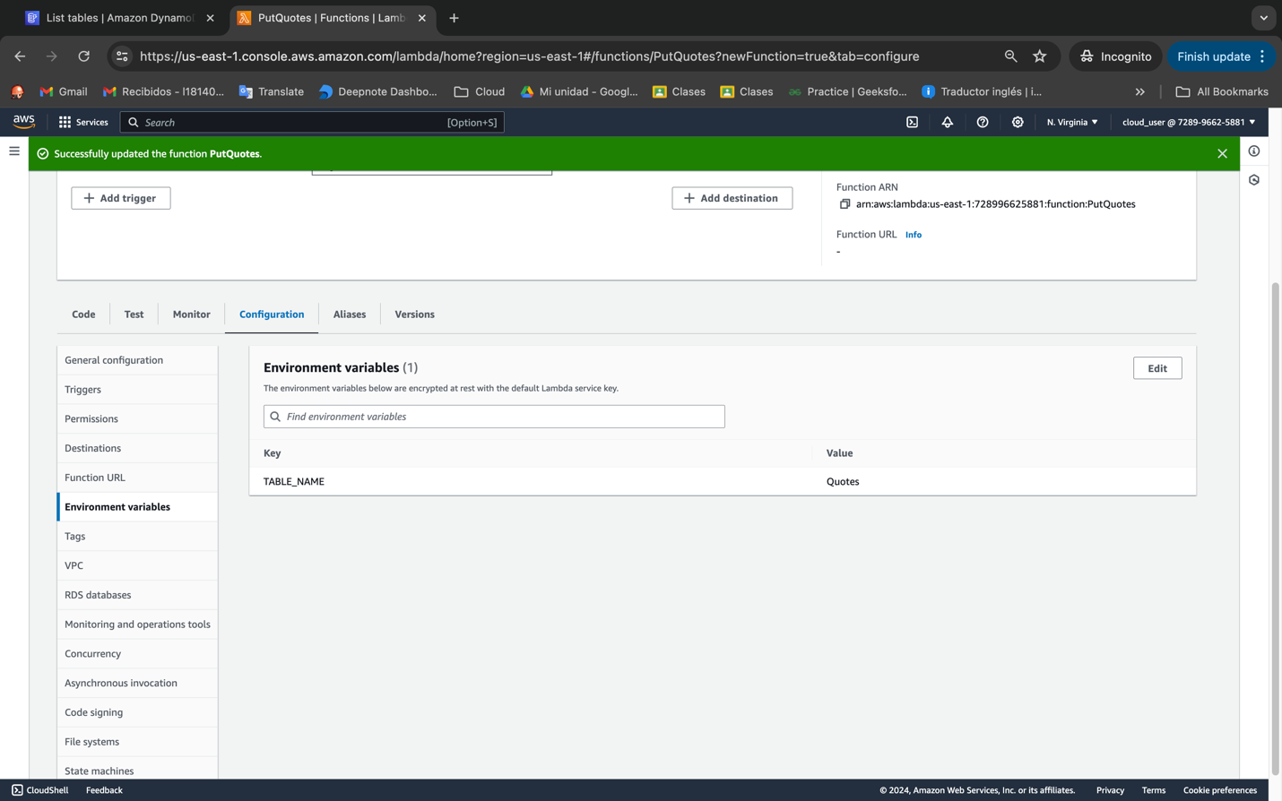

import boto3

from botocore.exceptions import ClientError

import http.client

import json

import os

TABLE_NAME = os.getenv("TABLE_NAME", default="Quotes")

def get_quote():

# Get a random quote from the internet

conn = http.client.HTTPSConnection("zenquotes.io")

conn.request("GET", "/api/random")

response = conn.getresponse()

if response.status == 200:

data = json.loads(response.read().decode())

quote = data[0]["q"]

author = data[0]["a"]

# Return the quote in the response

return {"quote": quote, "author": author}

else:

# Handle any potential errors

return {"body": f"Failed to fetch a quote. Error code: {response.status}"}

def put_quote(quote):

dynamodb = boto3.resource("dynamodb")

table = dynamodb.Table(TABLE_NAME)

item = {

"quote": quote["quote"],

"author": quote["author"],

}

try:

response = table.put_item(Item=item)

return "Quote successfully written to DynamoDB."

except ClientError as e:

print(e)

return "Error writing item to DynamoDB."

def lambda_handler(event, context):

return put_quote(get_quote())

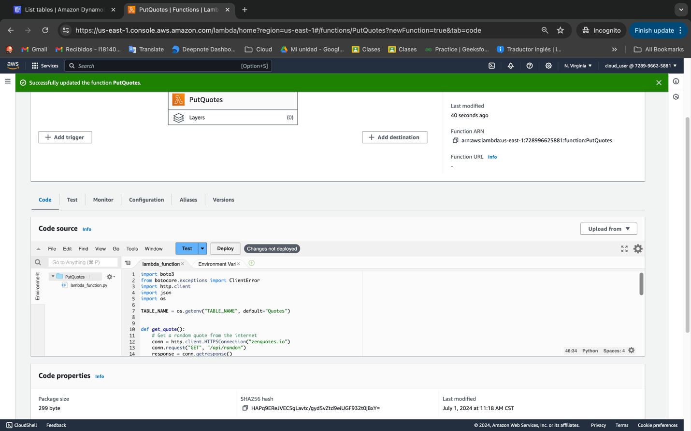

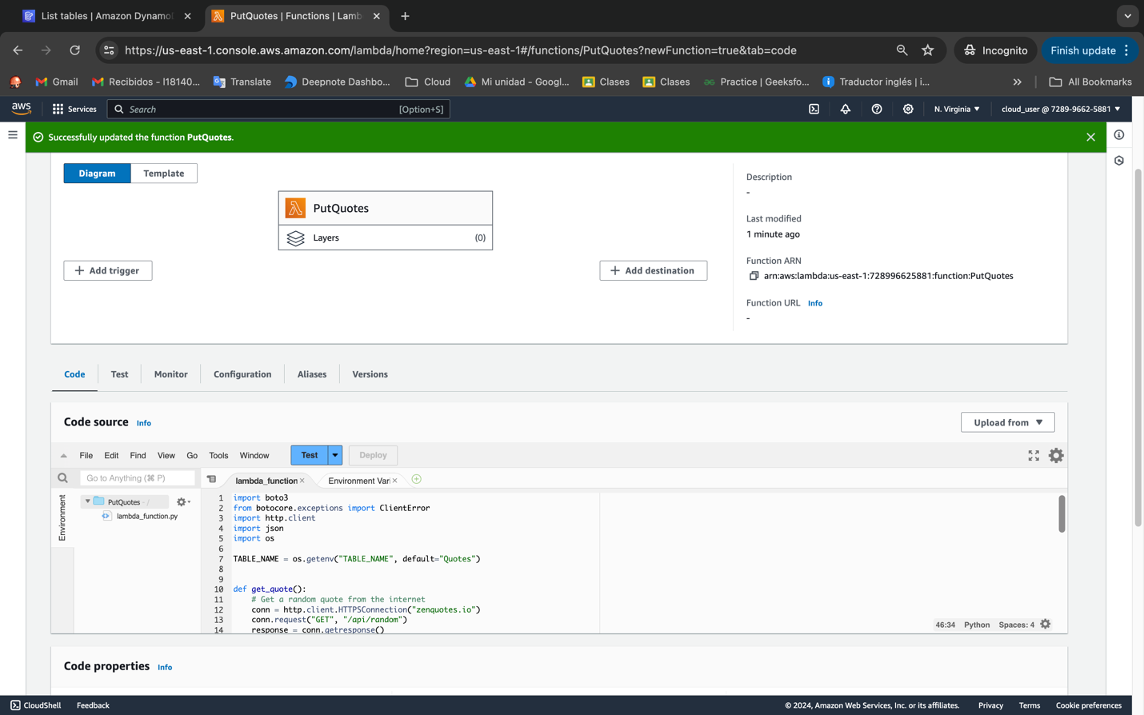

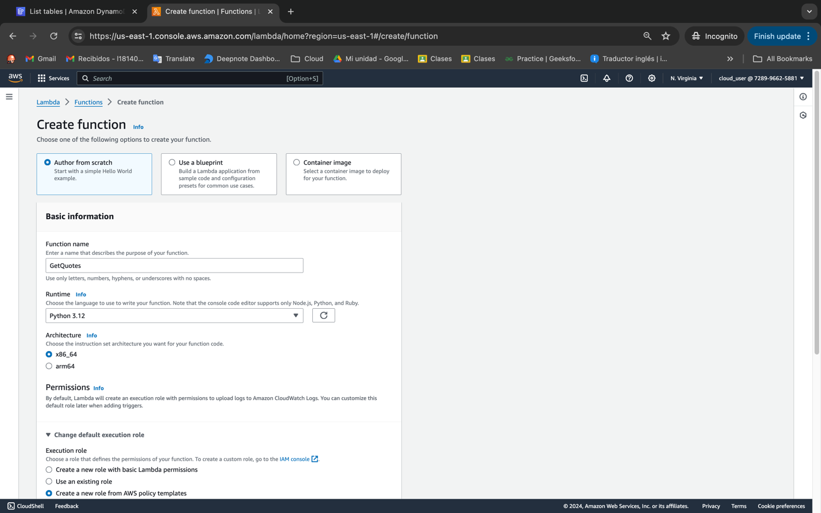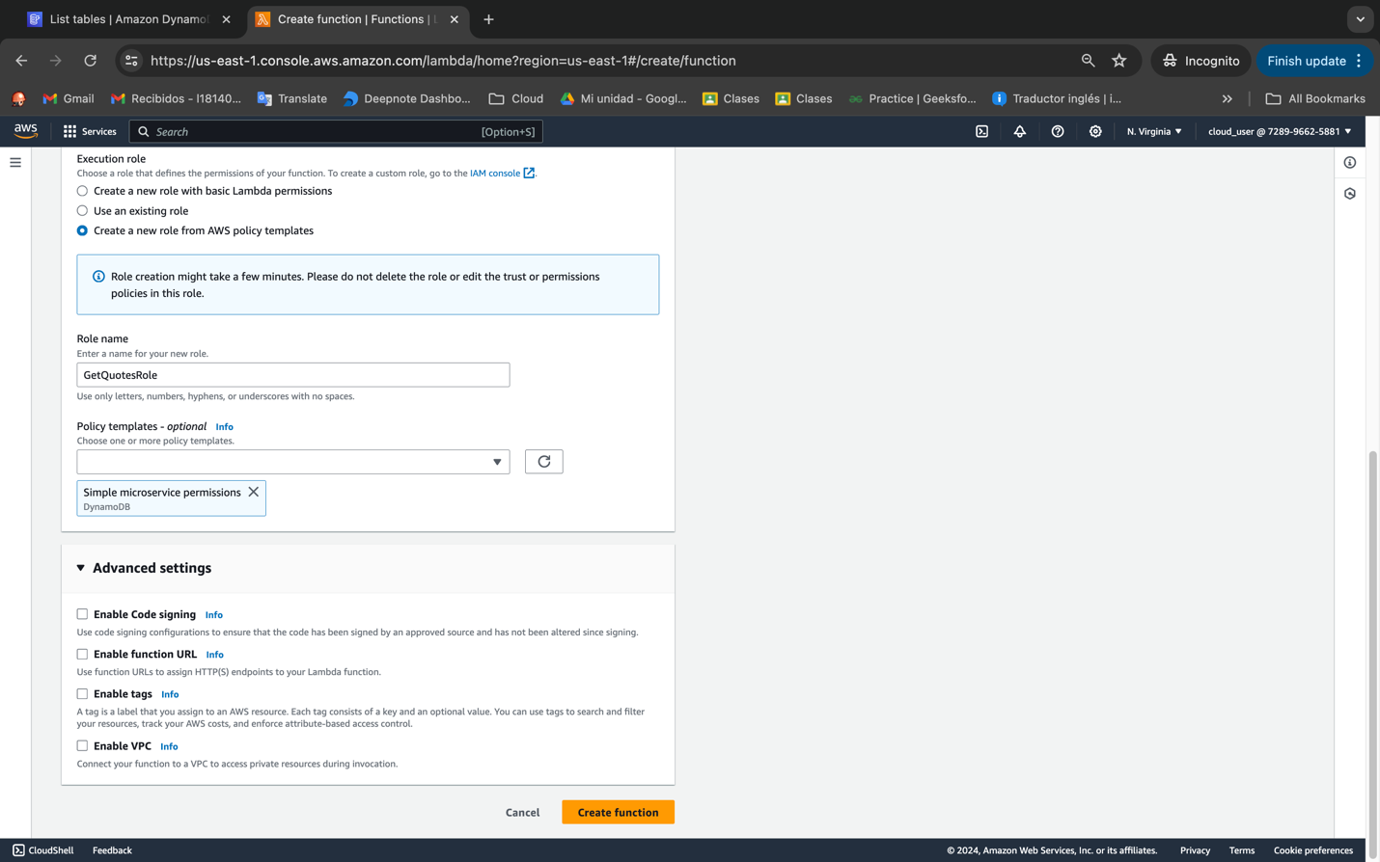

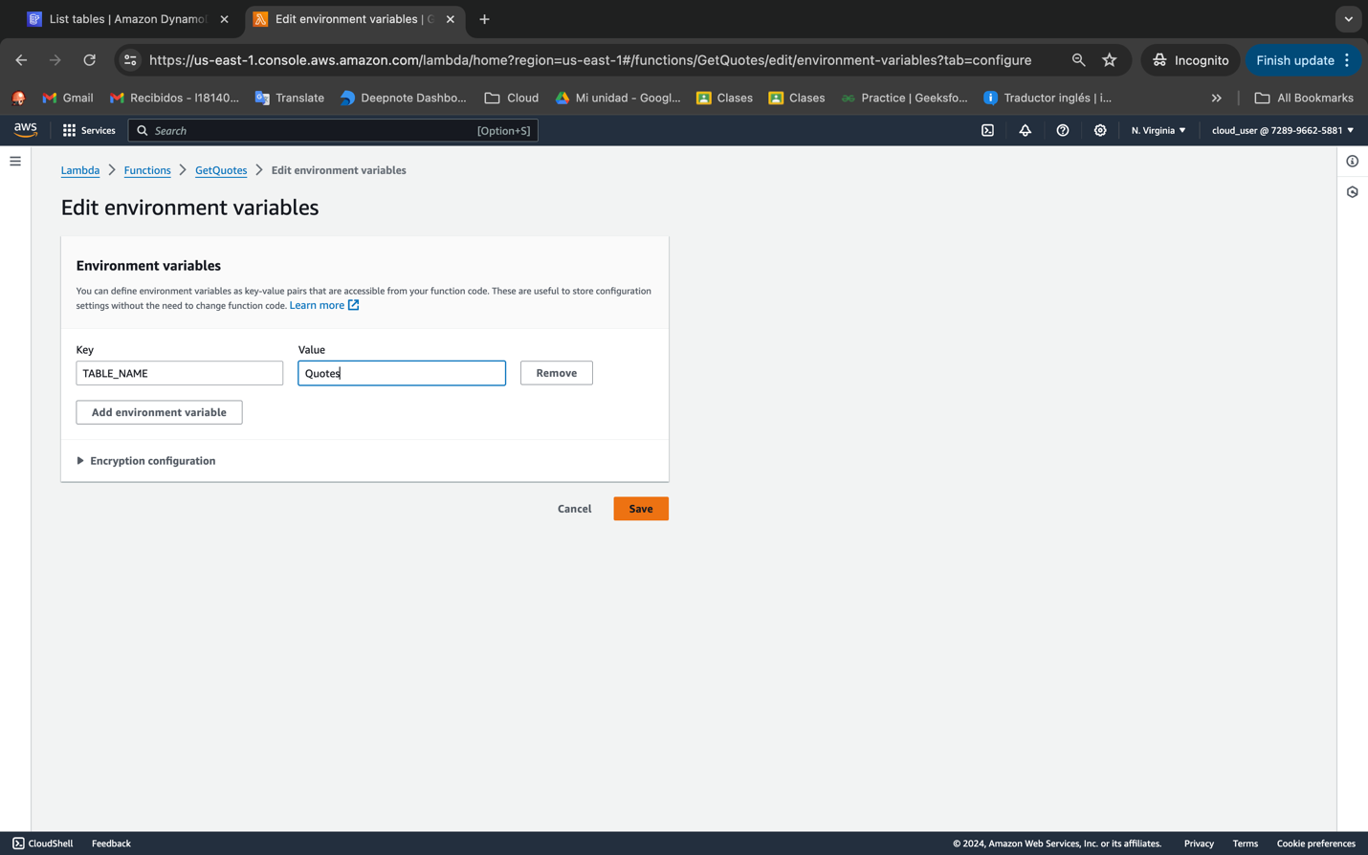

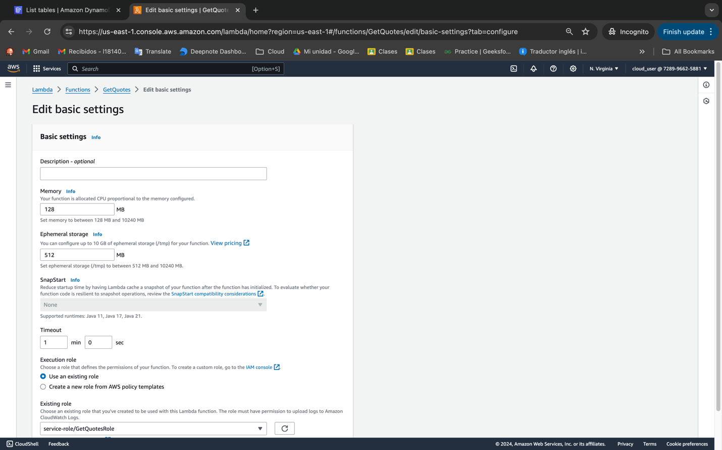

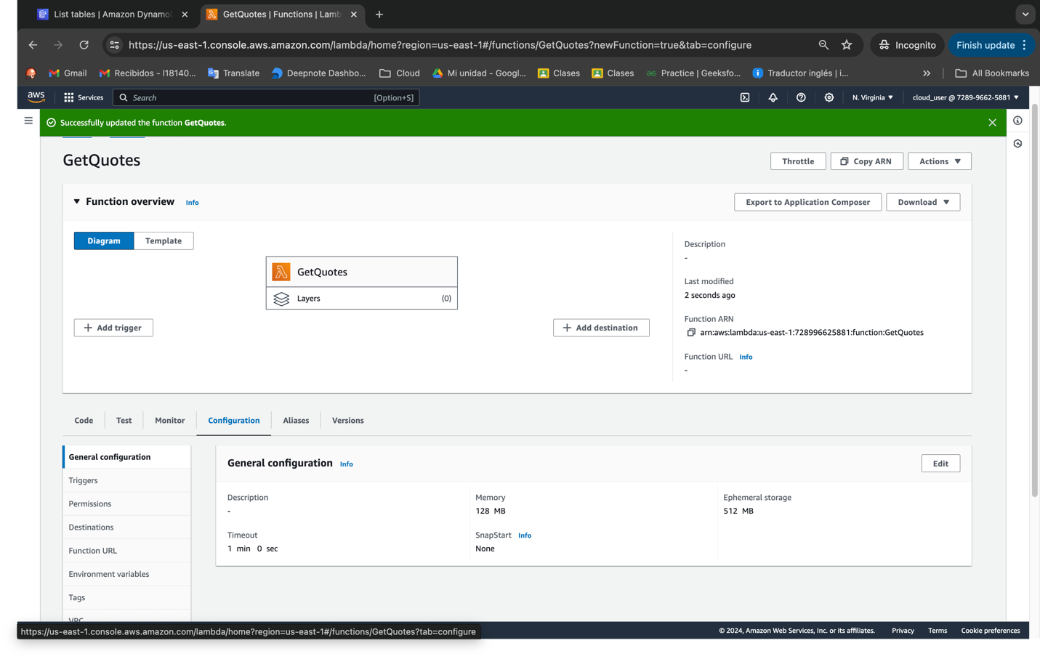

import boto3

from botocore.exceptions import ClientError

import random

import os

TABLE_NAME = os.getenv("TABLE_NAME", default="Quotes")

def lambda_handler(event, context):

dynamodb = boto3.resource("dynamodb")

table = dynamodb.Table(TABLE_NAME) # Replace with your DynamoDB table name

try:

# Perform the scan operation on the table

response = table.scan()

items = response["Items"]

# Check if the table has items

if not items:

return {"statusCode": 404, "body": "No items found in the table."}

# Select a random item

random_item = random.choice(items)

print(random_item)

return {"statusCode": 200, "body": f'{random_item["quote"]} -- {random_item["author"]}'}

except ClientError as e:

print(e)

return {"statusCode": 500, "body": "Error scanning the DynamoDB table."}

